SGM PRESCHOOL UNIFORM AND CLOTHING

Preschool students wear uniforms unique to our program.
- Shirts: Each child is asked to wear a hunter green polo or screened printed t-shirt with SGM Preschool Logo on it.
  - T-shirts, short and long sleeved, are purchased through Just Me Apparel. There are some shirts available through preschool. Check with administration for shirt sizes.
  - Green polo shirts with the logo, short and long sleeved, and polo dresses are purchased through Just Me Apparel or through SGM Used Uniform Sale held in May.
- Shorts/Pants/Skorts: Each child is asked to wear navy colored shorts/pants/skorts. No fleece, sweatpants, jeans, or jean like material are allowed. The parents have the discretion of what type of bottoms the child should wear depending on weather conditions. When the weather gets colder, the children are allowed to wear solid grey, black, white, or navy colored tights or leggings under the skorts, but they should not be worn instead of a skort.
- Polo Dresses: The hunter green dress is available for purchase at Just Me Apparel or through SGM Used Uniform Sale. They are available in short and long sleeve. Students need to wear shorts, tights, or leggings underneath their dress.
- Tennis shoes must be worn to school. Children should not wear sandals, slip on shoes, or boots to preschool.
- All children should have a change of clothes and underwear, clearly labeled with their name.
- During cold weather, please have your child dressed for 20 minutes of outdoor play. A sweater, jacket or sweatshirt may be left in case of changeable weather.

We ask that each student has at least one polo top (shirt or dress) to be worn on Atrium days, school pictures, and other special events.

**Yellow or white polo shirts are no longer part of the preschool uniform..**

Just Me Apparel
232 Old Sulpher Spring Road, Ballwin, MO 63021 (636) 391-3551

Preschool T-Shirts

The preschool t-shirts are white with St. Gerard Majella Preschool logo on them. There are several ways to purchase these t-shirts.

- Attend the SGM Uniform Exchange on May 30th.
- Order though Just Me Apparel.
  - Short Sleeve Shirts will be $12.50
  - Long Sleeve Shirts will be $16.50
- Purchase new shirts through school. In the past, school would purchase t-shirts and take orders. However, all uniforms now will be coming through Just Me Apparel. We still have several shirts in stock from past years. New orders are not being taken, but families are strongly encouraged to stop by school and purchase shirts of what we have left in inventory. YOU MAY PICK UP SHIRTS NOW. Don’t wait until the beginning of the year and save some money.

Short Sleeve T-Shirts $9.00 (varying sizes)
Long Sleeve T-Shirts $12.00 (varying sizes)

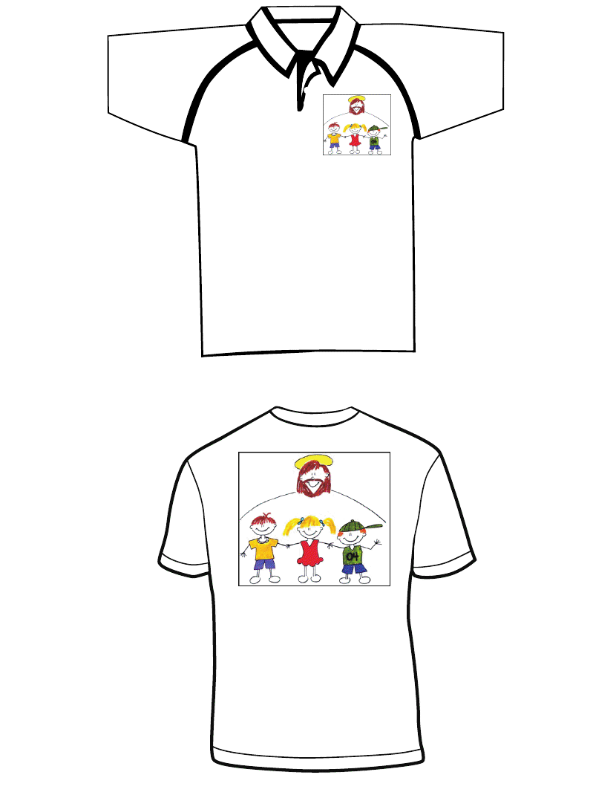

Questions? Contact Ms. Gintz at lgintz@sgmschool.org or call the school office 314-822-8844.

